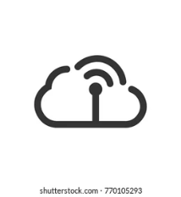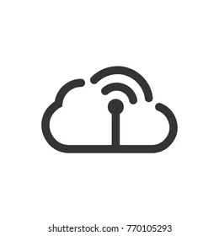

Google Firebase

Computing

Used Cars

Search Inventory

Request Service

New Cars

Sign Up/ Sign in

Cloud Services

PyQt5 application

Integration

Gateway

Event Handler

Analysis

Data Storage

MySQL

User/Buyer

Dashboard/ Apps/Welcome Screen

Applications